*The beginning of high school can be an uncertain time for a young person. They may experience isolation, a low mood, stress or even anxiety.* ***Your task is to create a “Tool Box*” with a variety of strategies that will assist in promoting positive mental health.***

|  |
| --- |
| **PART ONE** |
| **You need to describe one strategy to promote positive change for EACH of the 3 scenarios below:**   1. A friend is experiencing a mental health issue and has not been him/herself.   Take some time to talk to them, have a conversation, look at them in the eye and ask if they’re ok and talk about their mental state, listen to what they have to say, then suggest a resolution to their problems, and check in every now and then to see their progress.   1. You are experiencing stress or anxiety and need a way of coping.   Take a nap or meditate, looking through the R U OK Website, doing or playing something with someone that I enjoy, go outside and relax, maybe take dog for a walk while I’m out. To sum up, just generally doing something else to put my mind away from the issue, aka: Leisure.   1. A student new to the College and local area is feeling disconnected and very isolated from peers his age.   Try to introduce him to friends, find his qualities and try to match him with people with the same interests, stick around with them until they find friends or simply become their friend and start including them in your activities and friend groups. |
| **Follow the outline for each of your 3 strategy descriptions:**   * 1. *A description of the strategy and how it works.*   2. *An explanation of how the strategy will promote positive change.*   3. *The cost of the strategy (if any) and description of the strategy’s accessibility for this person.*   4. *An evaluation of the strategy’s effectiveness either from personal experience or research/evidence*   *\*Mode of presentation for Part A:*  *Microsoft Word, PowerPoint, Publisher or any other software of teacher’ choice*. |
| **PART TWO** |
| **You need to provide detailed information on an available resource you or a friend could access for any possible mental health issue or illness.** |
| **For the resource of your choice, you need to:**   * 1. Detail name of the resource, who they are and their history.   2. Explain the services they offer and how to access them.   3. Identify how they promote positive mental health.   4. Explain how you access the information or services they provide.   *\*Mode of presentation for Part B- same as Part A.* |

**Part One: Model example**

**Strategy 2: *You are experiencing stress or anxiety and need a way of coping.***

*Stress Ball*

1. 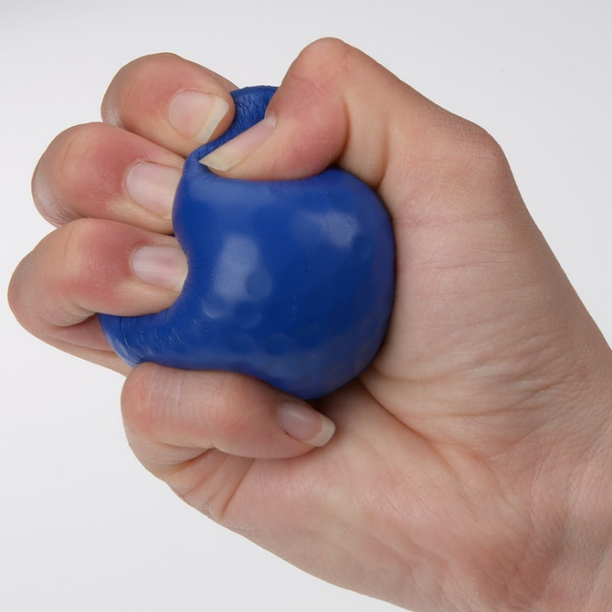A description of the strategy and how it works.

*A stress ball is a malleable toy, usually not more than 7 cm in diameter, which is squeezed in the hand and manipulated by the fingers, ostensibly to relieve stress and muscle tension or to exercise the muscles of the hand.*

1. An explanation of how the strategy will promote positive change.

*A stress ball relates to stress management techniques and relaxation activities because as we get stressed our body tenses up and by squeezing the stress ball this can leave you less tense than before. It’s also helpful for promoting blood flow around the body, and acts as a muscle strengthener for the hand muscles. It can also take your mind off what may be causing the stress and turning that focus to the stress ball.*

1. The cost of the strategy (if any) and description of the strategy’s accessibility for this person.

*A stress ball is inexpensive.**You can get a stress ball for about 2 dollars or you can make your own using readily available household items such as a balloon and rice. Any young person should have access to a retailer who stocks stress balls.*

1. An evaluation of the strategy’s effectiveness either from personal experience or research/evidence

*I have used a stress ball before. It was useful in shifting my focus from worrying thoughts to manipulating the ball. Also, multiple studies have found that squeezing stress balls can improve focus by giving the brain a break leading to reduced stress and anxiety.*

***Resources:***

*Talk, Listen, Suggest Strategies, and Check In*

1. A description of the strategy and how it works.

*This strategy involves 4 steps; Talk, where you check in with someone you feel isn’t mentally healthy or has an issue. Ask “are you ok?” Listen, where you take in everything that person has to say to you and imagine yourself in their shoes (empathy). Suggest Strategies, where you suggest ways to combat the issue and come up with a resolution that’ll make the friend healthy again. And Check In, where after suggestion strategies, you check in with them every 3 days or so, to see their progress.*

1. An explanation of how the strategy will promote positive change.

*As shown and heavily promoted by R U OK, the Talk, Listen, Suggest, and Check In strategies works well to promote positive changes. It allows whoever is being asked the question to open up, as the asker assures them that they’ll be here throughout their journey to get well. Talking and listening allows you to identify the issue at hand, suggesting strategies allows certain tactics that can help out to be put into play. Checking In gives you more insight on their current mental status, and can indicate if your friend is getting better, or if more action is needed.*

1. The cost of the strategy (if any) and description of the strategy’s accessibility for this person.

*Words cost no money, only courage from both parties. The friend of the mentally unwell has the ability to talk at anytime, whether they choose to do so it up to them.*

1. An evaluation of the strategy’s effectiveness either from personal experience or research/evidence

*I feel that this strategy works well, all according to R U OK. They heavily promote this strategy and shows true stories and results of the strategy. Definitely effective.*

*Do an activity that you enjoy, so you can take your mind off the matter*

1. A description of the strategy and how it works.

*Essentially, when you run into or are reminded of an issue, you take your mind off it by instead doing something else you enjoy. This could include going outside, playing video games, taking the dog for a walk, going to a park, or something smaller like napping. This postpones the negative issue and allows you to take time and do what you love.*

1. An explanation of how the strategy will promote positive change.

*I feel that the idea of doing something positive which takes your mind off something negative, is a both good and potentially irresponsible positive change. It’s good in that it takes your mind off something and allows you to do something that you like, coming back when you’re ready to face the issue. The problem is that if someone were to always run away from their problems like this, and never goes back to solve them. That’s unlikely to happen, but not impossible. Although, generally a positive change.*

1. The cost of the strategy (if any) and description of the strategy’s accessibility for this person.

*The cost really just depends on what you decide to do instead. This can range from n no cost for something as simple as going to the park or taking a nap, and a bit more expensive with video games and pets.*

1. An evaluation of the strategy’s effectiveness either from personal experience or research/evidence

*I use this strategy a lot and I do think it is effective. It does a good job at resetting my mind and preparing myself to handle what I would just avoid before.*

*Trying to introduce to friends, or become their friend*

1. A description of the strategy and how it works.

*The idea is simple but the execution has a chance for variety. You confront the sadden individual and you attempt to find them friends. This can be done by learning their interests and trying to match them with the same interests as others, or by finding something new that they’re good at and searching from there, although any way could work. If nothing works however, simply becoming their friend or including them in your friend group could also be very helpful.*

1. An explanation of how the strategy will promote positive change.

*This method promotes positive change within the person finding a friend, as they feel good about helping another person out. Of course, the other person in need for friends is heavily benefited from this strategy as well, as they find friends that they could keep potentially forever. Both people are changed positively by this strategy.*

1. The cost of the strategy (if any) and description of the strategy’s accessibility for this person.

*The only cost is courage, empathy, and being willing to have this new person be a friend or having the courage to find that person new friends. So, overall, there is no real cost.*

1. An evaluation of the strategy’s effectiveness either from personal experience or research/evidence

*I personally haven’t experienced this myself, as I haven’t been in the shoes of either party, but this strategy does seem to work well outside of that.*

Some resources used for this and that are useful for dealing with mental health include

o beyondblue.org.au

o kidshelp.com.au

o ruok.org

***Year 8 Achievement Standards Evident In This Assessment***

* Students investigate strategies and resources to manage changes and transitions and their impact on identities. (1)
* They analyse factors that influence emotional responses.(3)
* They gather and analyse health information.(4)
* They investigate strategies that enhance their own and others’ health, safety and wellbeing.(5)
* They justify actions that promote their own and others’ health, safety and wellbeing at home, at school and in the community.(9)

|  |  |  |  |  |  |
| --- | --- | --- | --- | --- | --- |
| **Achievement Category** | **NP – UG**  **V.LOW / not covered** | **D+ - D**  **LOW** | **C+ - C**  **AVERAGE** | **B+ - B**  **VERY GOOD** | **A+ - A**  **EXCELLENT** |
| **Investigation: Strategies & Resources for Health Promotion**  **(1, 5)** | Investigation either not completed OR contains very little detail.  Toolbox items do not reflect the needs of the task appropriately. | Investigation of strategies and resources is basic. Little thought given to the choice of Toolbox items required. Does not reflect the requirements of the task satisfactorily. | Investigation completed to a satisfactory standard.  Toolbox items provided reflect the requirements of the task. | Investigation completed in some detailed manner. Toolbox items provided reflect the requirements of the task to a high degree. | Investigation completed in a detailed and comprehensive manner. Toolbox items provided are high creative and meet the requirements of the task. |
| **Analyse:**  **Factors influencing emotional response & health info**  **(3, 4)** | Absence or severe lack of understanding of how to analyse information from various sources.  No application of research to task given | Ability to take information from various sources and critically analyse it with a limited degree of accuracy.  Information/tool is inappropriate for the intended audience | Ability to take information from various sources and somewhat critically analyse it to find the most accurate information.  Information/tool is somewhat appropriate for the intended audience | Ability to take information from various sources and critically analyse it to find the most accurate research.  Information/tool is appropriate for the intended audience. | Ability to take information from various sources and critically analyse it with a high degree accuracy and detail.  Information/tool is highly appropriate and original for the intended audience. |
| **Justification: actions promoting health, safety and wellbeing (9)** | No statements have been included justifying the choice of each toolbox item. | Statements have included some basic information justifying the choice of each toolbox item. | Statements have included some information, which support, with explanations or examples, justifying the choice of each toolbox item. | Statements have included some detail which support, with explanations or examples, justifying the choice of each toolbox item. | Statements have been detailed thoroughly which fully support, with explanations or examples, justifying the choice of each toolbox item. |